*Jahangirnagar University*

*Computer networking Lab*

*Lab report 5*



Course Title: Computer Networking laboratory

Course Code: CSE-402

Submitted by:

Name: Md. Omar Faruque Abir

Roll: 44

Submitted Date : 17-10-2019

**Name**: Configuration of DNS server

**Introduction:** DNS ( domain name server ) or Domain Name System translates domain names into IP addresses. Domain names are easier to remember, but the internet is based on IP addresses. Every website has an IP address that is its internet location. DNS (Domain Name System) is the largest database of information about every website on the internet.

**The purpose of DNS**

To use easy-to-remember domain names for websites instead of their numeric IP addresses. For example, the domain name www.email-freeplan.com might be translated to 198.105.232.44. The data that tells the web server how to respond to your input is known as the DNS records or zone files. These records play a significant role in the functionality of the internet.

DNS syntax is a set of commands that dictate the actions of the DNS server. The most used records stored in the DNS database are IP addresses like A and AAAA; domain name aliases like CNAME; SMTP mail exchangers like MX; pointers for reverse DNS lookups like PTR; and name servers like NS or Start of Authority (SOA).

**Objective:**

We will simulate a network with two DNS server under different network connected via a router and check whether pc in different network can connect to a DNS server written by its name.

**Network Layout:**

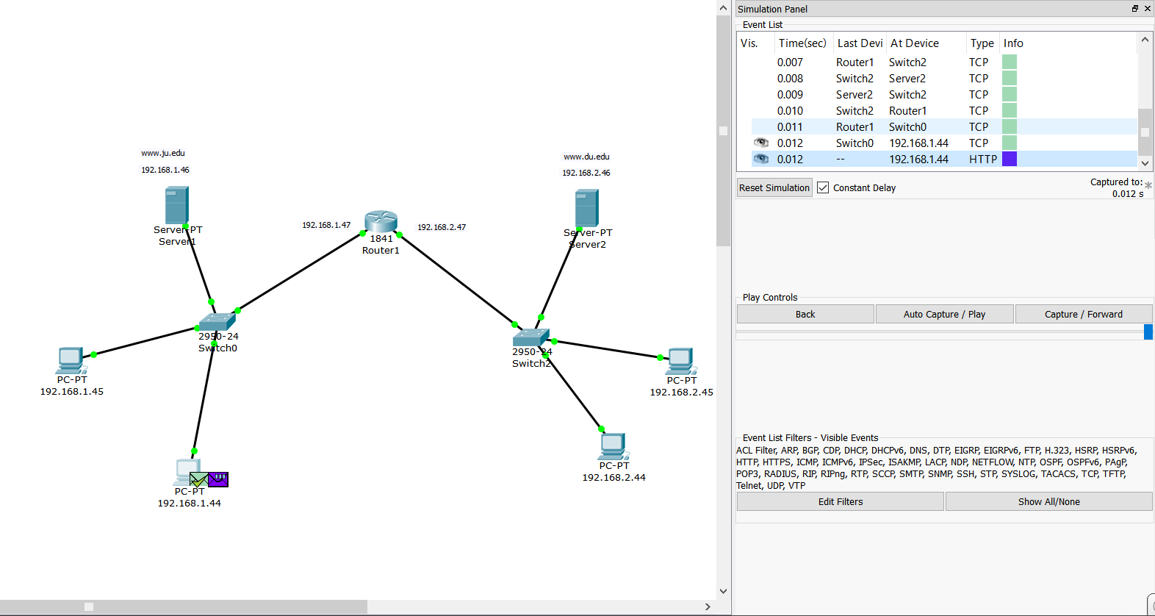

**DNS service configuration:**

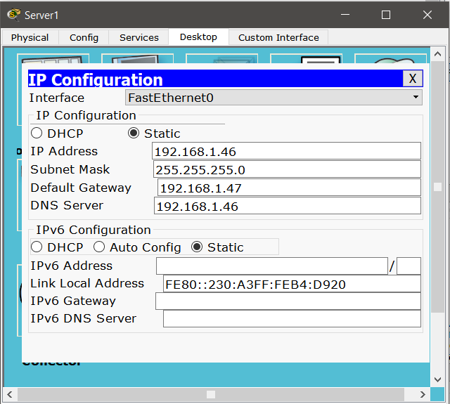

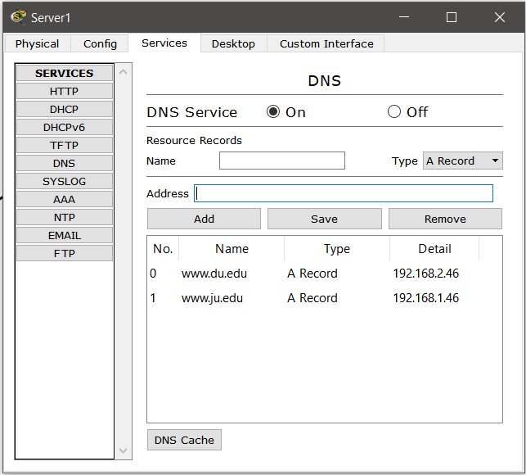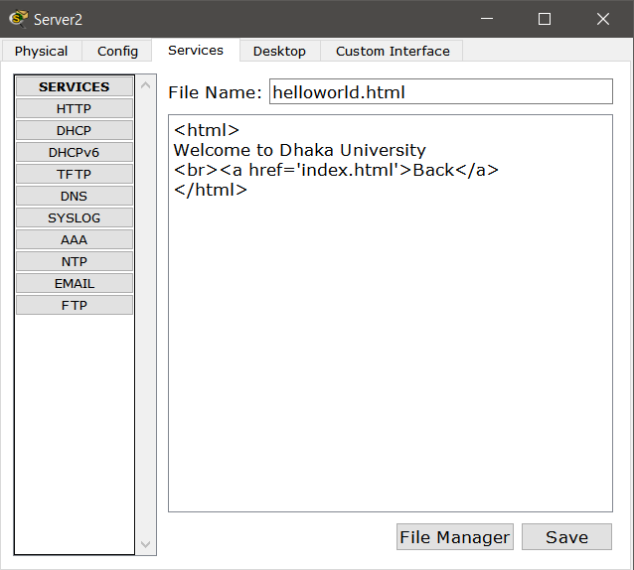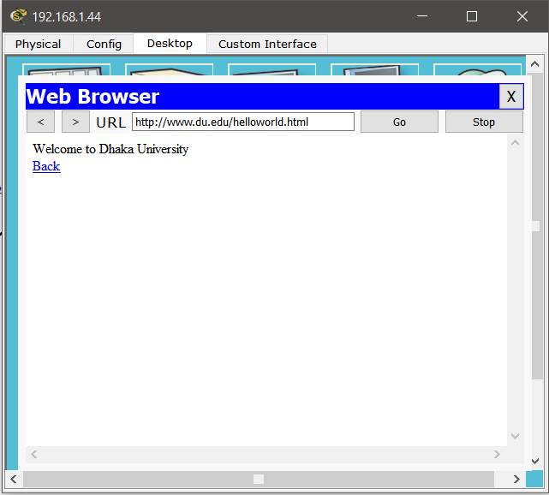

**Conclusion:**

We can clearly observe that Instead of typing the actual IP address we can access this particular page via its Domain Name. So the experiment is valid.